Name: ___________________________ Date: ___________________ iPad: ______

TOPIC #2
ATOMIC STRUCTURE
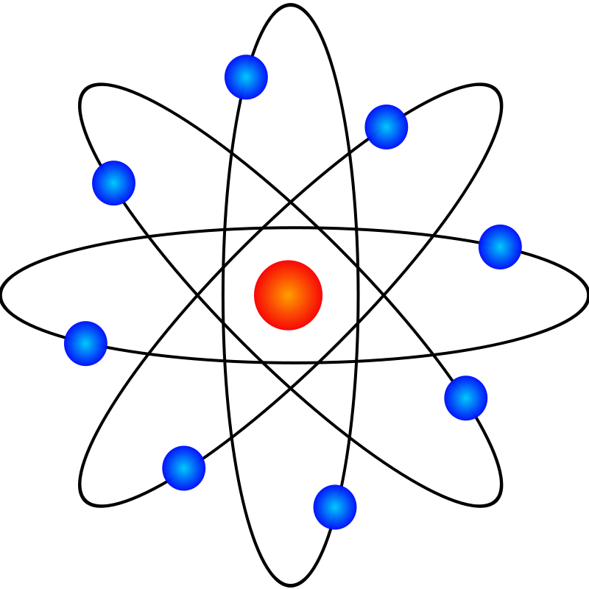

Homework Due: Monday, October 5, 2015

Exam Dates: Free Response: Wednesday, October 7
Multiple Choice: Thursday, October 8

Textbook: Chapter 4 & Chapter 5 (pgs. 102 – 157)
Topic #2 Atomic Structure Study Guide
Historical Background:
- History of atomic structure and the electrical nature of the atom and its particles involve key scientists including Dalton, Thomson, Rutherford, Bohr and others.
- One scientist’s discoveries leading the way for the next.

Parts of the Atom (Subatomic Particles) & Reference Table O
- The atom is composed of the nucleus & electron shells (principle energy levels).
- Nucleus: The nucleus is composed of nucleons.
  - Nucleons: all particles in the nucleus (protons & neutrons)
    - Protons: positively-charged, found in nucleus, mass = 1 AMU
    - Neutrons: neutrally-charged, found in nucleus, mass = 1 AMU
- Shells/Principle Energy Levels (PELs):
  - Electrons- negatively-charge, orbit around the nucleus, has very little mass (1/1836 of a proton or 1/1836 amu)
- Net (overall) charge of an atom is 0 (neutral)
- Nuclear charge: based on the # of protons in the nucleus
- Atomic number = # of protons and in a neutral atom (also the # of electrons)
- Atomic mass/ Mass Number = # of protons + # of neutrons
- Calculating the # of neutrons use the formula: Atomic Mass – Atomic Number
- Isotopes are atoms of the same element with different mass (different # of neutrons); calculate average isotopic mass using the weighted average of the naturally occurring isotopes
- Kernel: symbol of element representing the nucleus and all electrons except the valence electrons
- Atomic and Ionic and Radii
  - Metals tend to lose electrons, become positive ions with a smaller radius than its atom
  - Non-metals tend to gain electrons, become negative ions with a larger radius than its atom
- Radioactive Decay Particles: Look for decay particles on chart O
  - Alpha (helium nucleus)
  - Beta (electron)
  - Gamma
- Separating nuclear decay particle emission
- Alpha - positive particle deflects toward negative pole
- Beta – negative particle deflects toward positive pole
- Gamma – neutral particle unaffected by the charge of the poles

Models of the Atom (Subatomic Particles) & Reference Table O
- John Dalton: The Billiard Ball/Cannonball Model
- J.J. Thomson: The Plum Pudding Model
- Ernest Rutherford: The Planetary Model
- Niels Bohr: The Bohr Model
- Heisenberg & Schrodinger: The Wave Mechanical Model/The Electron Cloud Model/The Modern Atomic Theory
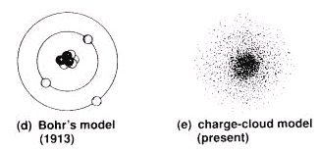
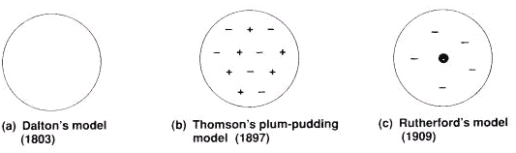

Arrangement of Electrons Outside the Nucleus
- Ground State: electrons occupy the lowest available energy levels.
- Excited State: the condition that exists when the electrons of an atom occupy higher energy levels while lower energy levels are vacant.
- Spectral lines
  - Absorption of energy causes electrons to jump to higher levels
  - Emission of energy occurs when electrons fall back to their original location

Modern Atomic Structure Theory
- Electron Cloud Model of the atom and understanding all notations
    - Principal energy level (PEL)- All sublevels with the same coefficient (big number in front)
    - Sublevels- Any letter after a coefficient (s,p,d,f)-representing the area of probability of locating an electron.
    - Orbital –a region in an atom in which an electron of particular amount of energy is probably located.

Coefficient represents PEL→ 2 s 3 ← superscript represents the # of electrons
Orbital Diagrams
  - Remember the sublevels Smart People Don’t Fail
  - Remember how to fill the orbitals of a particular sublevel; put an ↑ in each orbital before placing the second electron - up up up (↑↑↑)… then down down down (↓↓↓) …
  - Look for the words …. Half filled, occupied and completely filled
  - Electrons fill shells from lowest to highest energy.
- Hunds rule/Octet rule: stable valence electron configuration of eight electrons

SUMMARY
Principal Energy Level | Sublevel | Obitals | # of electrons
1 | s | 1 | 2
2 | s, p | 1, 3 | 2, 6
3 | s, p, d | 1, 3, 5 | 2, 6, 10
4 | s, p, d, f | 1, 3, 5, 7 | 2, 6, 10, 14

Table S
- Ionization energy: amount of energy needed to remove the most loosely bound electron from a neutral atom.
- Electronegativity: a measure of the attraction of a nucleus for a bonded electron.

Key Vocabulary
Atom excited state neutron valence electron
Atomic mass ground state nucleus valence shell
Atomic mass unit isotope orbital spectral lines
Atomic number mass number proton nucleons
Electron neutron element
Nucleons PEL ion

Topic # 6 Atomic Structure Homework

Section A: The Atom
- Use your textbook to define the term “atom”:
______________________________________________________________________________________________________________________________________________________________________

- Complete the Subatomic Particles chart below (See textbook pg. 107.)
Particle | Symbol | Charge | Mass (u) | Location of Particle | Relative Mass
Proton
Neutron
Electron

- What is the difference between “net charge” and “nuclear charge”?
Net Charge | Nuclear Charge

- Complete the chart below:
Symbol | Atomic number | Atomic mass/  Mass number | Number of protons | Number of electrons | Number of neutrons | Atomic Charge | Nuclear Charge
 |  |  |  |  | 0
 | 1 | 3
 | 46 |  |  |  | 61
 |  |  | 5 |  | 6
 |  | 208 | 82
 |  |  |  | 43 | 54

Textbook Page 118:
#30: ____________________________________________________________________________________
_________________________________________________________________________________________

Textbook Page 122:
#45: __________

#47: ____________________________________________________________________________________
_________________________________________________________________________________________
Section B: Radioactive Decay Particles
- Label the rays at A, B and C as radiation passes through a magnetic field.
+ A) __________________ (deflected toward positive pole)

B) ___________________ (no deflection)

_ C) ___________________ (deflected toward negative pole)

- Complete the chart below: (Use Reference Table O.)
Decay Particle | Notation | Greek Symbol | Charge of particle
Alpha
Beta
Gamma

- Which nuclear emission, moving through an electric field would be deflected toward the positive electrode? Explain why.
______________________________________________________________________________________________________________________________________________________________________

- The structure of an alpha particle is similar to what atom or element? What is the difference between the two?
______________________________________________________________________________________________________________________________________________________________________

Section C: Models of the Atom
- Draw diagrams of Thomson models of a boron atom and a fluorine
atom.

Boron Fluorine

- Describe the limitation with Rutherford’s model of the atom.
______________________________________________________________________________________________________________________________________________________________________

Textbook Page 109
#13: Rutherford’s Gold Foil Experiment
Expected Outcome: | Actual Outcome:

#14: __________________________________________________________________________________________________________________________________________________________________________________

#15: Rutherford’s Atomic Model vs. Thomson’s Atomic Model
Rutherford: | Thomson:

Textbook Page 152:
#27: ____________________________________________________________________________________
_________________________________________________________________________________________

Pearson SuccessNet On-Line
Go to: Chapter 4 → Chapter-Level Activities → Ch. 4 Directed Virtual Lab: Rutherford’s Experiment. Answer all questions and submit.
Go to: Chapter 4 → Chapter-Level Activities → Ch. 4.2 Kinetic Art – Cathode Ray. Answer all questions and submit.

Section D: Ions
- Use your textbook to define the term “ion”:
______________________________________________________________________________________________________________________________________________________________________

- Complete the table for the composition of the following ions.
Symbol | Na |  | As
Ion charge | 1+ |  | 3-
# of protons |  | 4
# of neutrons | 12 |  | 42 | 10
# of electrons |  | 2 |  | 10
Atomic # |  |  |  | 9
Mass Number |  | 9
Section E: Isotopes

- Cobolt-60 is used in the radiation therapy to treat cancer. How many neutrons does each cobalt-60 atom contain? ________
What is a disadvantage to using radioactive isotopes in medical procedures? ______________________________________________________________________________________________________________________________________________________________________

- Calcium has five stable isotopes. How do these isotopes differ from
one another? How are they similar?
______________________________________________________________________________________________________________________________________________________________________

Textbook Page 116:
#4.3 (Interpret Data)
a) _______
b) ________________________________________________________________________________

Textbook Page 122:

#52: ____________________________________________________________________________________
_________________________________________________________________________________________

#64: Calculating the average atomic mass of lead

Textbook Page 156
#106: ___________________________________________________________________________________
_________________________________________________________________________________________
_________________________________________________________________________________________

Section F: Electrons in Atoms

- Fill in the information for the element Sulfur
- Nuclear charge: ___________
- Number of neutrons: ___________
- Symbol of element: __________
- Electron configuration (from Periodic Table): _________________________
- Representative electron configuration (ex: 1s²2s²…): ______________________
- Noble gas configuration: ____________________________________________
- P.E.L. # of valence energy shell: ___________
- Number of valence electrons: __________
- Possible oxidation numbers that will obtain an octet: ___________
- Fill in the orbital notation below:

___ ___ ___ ___ ___ ___ ___ ___ ___ ___ ___ ___ ___ ___ ___ ___ ___ ___
1s 2s 2p 3s 3p 3d 4s 4p

- Number of occupied sublevels: ______________
- Number of half-filled orbitals: __________
- Number of completely filled principle energy levels: __________
- Kernel of this atom includes: ____ protons, ______ neutrons, ______ electrons
- A possible excited state electron configuration: _____________________________
- Electron dot diagram

Textbook Page 132:

#1: _____________________________________________________________________________________
_________________________________________________________________________________________

#2: _____________________________________________________________________________________
_________________________________________________________________________________________

#3: _____________________________________________________________________________________

#4: _____________________________________________________________________________________
_________________________________________________________________________________________

Textbook Page 152:
#31: ____________________________________________________________________________________
_________________________________________________________________________________________

#35: ____________________________________________________________________________________
_________________________________________________________________________________________

#40:
a) _________ b) _________ c) _________ d) _________

#56:
a) _________ b) _________ c) _________

#61: ______

Textbook Page 154
#73: ____________________________________________________________________________________
_________________________________________________________________________________________
_________________________________________________________________________________________

#77:
- What’s wrong with the diagram?
________________________________________________________________________________

Correct Orbital Diagram: ___ ___ ___ ___ ___

- What’s wrong with the diagram?
________________________________________________________________________________

Correct Orbital Diagram: ___ ___ ___ ___ ___

Section G: Bright Line Spectra
- Use your textbook glossary to define the following terms:
  - Ground state: ______________________________________________________________
_____________________________________________________________________________
  - Excited state: _____________________________________________________________
_____________________________________________________________________________

- Write the electron configuration for potassium in the ground state: _________
Write an electron configuration for potassium in the excited state: _________

- Based on the Bright Line Emission Spectra below, answer the questions that follow.
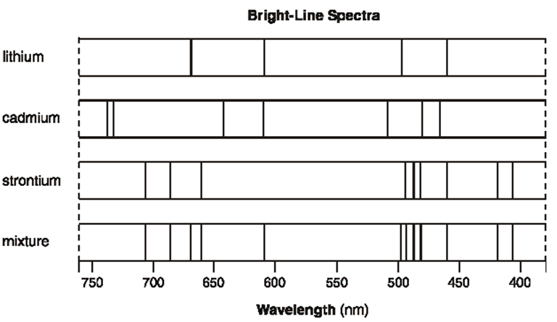

- Identify all elements in the mixture. __________________________________
- Explain, in terms of both electrons and energy, how the bright-line spectrum of an element is produced.
___________________________________________________________________________________
___________________________________________________________________________________

Textbook Page 141:

#15: Does this radiation have a longer or
shorter wavelength than red light?
___________________________

Reading in the Sciences Assignment
Answer the questions after reading the article entitled "Making New Elements How Scientists Create Superheavy Atoms," Popular Science, May 2013.

1. What is so unusual and significant about creating the element 119?

2. Summarize the 4-step "recipe" for creating element 119.
1.
2.
3.
4.

3. Name the 2 elements that "smash" together to create element 119.

_____________________ and _____________________

4. What is an alpha particle?

5. Why do scientists need to detect alpha particles?

6. What does I.U.P.A.C. stand for?

7. Complete the atomic symbol for element 119 with the appropriate information.

atomic mass
symbol symbol/kernel
letters

atomic
number

8. To date, have the scientists been successful in detecting the presence of element 119?

